**Things You Need to Know About Linux Before Starting Linux**

**Early Roots (1960s–1980s)**

* **Unix (1969–1970s):** Developed at AT&T Bell Labs, it became a multiuser, multitasking operating system. Unix laid the groundwork for Linux. However, UNIX was not free, which created a need for **open-source** free software for everyone.

**The Birth of Linux (1991)**

* **Linus Torvalds** started developing the Linux kernel as a hobby project.
* **First Release:** On **August 25, 1991**.

**Growth & Open Source (1990s)**

* **GNU Project:** Richard Stallman’s **Free Software Foundation (FSF)** had already started the **GNU Project**, aiming to create free software to replace proprietary Unix. It provided essential tools like **compilers, libraries, and the shell (bash)**.
* **Linux + GNU:** The Linux kernel was paired with GNU software, creating a complete operating system.

**Widespread Adoption (2000s–Present)**

* **Linux Distributions:** Popular distributions like **Red Hat, Debian,** and **Ubuntu** made Linux more accessible, catering to a broad audience, including developers, businesses, and home users.
* **Web Servers & Data Centers:** Linux became the preferred choice for web servers and data centers, known for its **reliability, high performance,** and **cost-efficiency**.
* **Android:** Based on the Linux kernel, the **Android** operating system grew to become the leading mobile OS, expanding Linux's influence in the mobile sector.
* **Git:** Created by **Linus Torvalds**, **Git** emerged as a version control system and became widely adopted in the software development community.
* **Ongoing Impact:** Linux continues to excel in diverse fields such as **server management, cloud computing,** and **embedded systems**, and remains a cornerstone of the open-source movement.

**Basic Features of Linux**

* **Portable:** The Linux kernel and application programs can be installed on any type of hardware platform.
* **Open Source:** Linux source code is **freely available** and completely free.
* **Multi-User:** Linux has a **multi-user system**, which means multiple users can access it at the same time.
* **Shell:** Linux provides a **special interpreter** that can be used to execute commands for the operating system.
* **Security:** Linux is **highly secure** and a widely used OS.

**Comparison Between Unix and Linux**

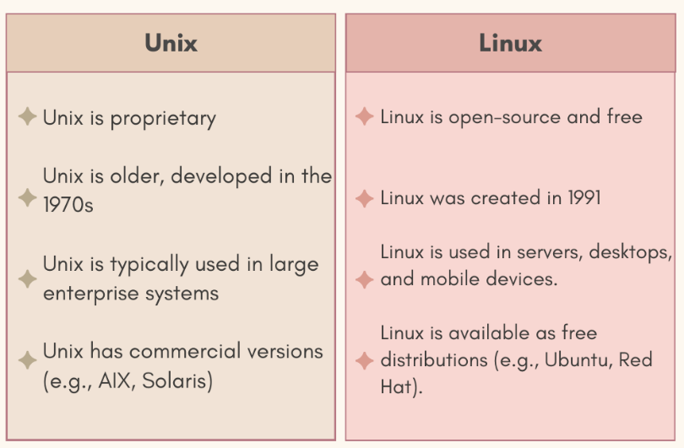

**Popular Linux Distributions**

1. **Red Hat Enterprise Linux**
2. **Fedora Linux**
3. **Debian Linux**
4. **SUSE Enterprise Linux**
5. **Ubuntu Linux**

**Layered Architecture**

Linux follows a layered system architecture consisting of:

* **User Layer** (Users and Applications)
* **Shell Layer** (Command Interpreter)
* **Kernel Layer** (Core of the OS)
* **Hardware Layer** (Interacts with physical components)

**Layered Architecture of Linux**

Linux follows a layered system architecture consisting of:

* **Hardware Layer:** This layer includes all the physical devices, like **RAM, HDD, CPU**, and peripherals that the system interacts with.
* **Kernel:** The core component of the operating system. It manages hardware resources, provides low-level services to the system, and acts as an intermediary between the hardware and the user.
* **Shell:** This is the interface between the user and the kernel. The shell takes user commands, processes them, and communicates with the kernel to execute the appropriate functions, hiding the complexity of the kernel's operations.
* **Utilities:** These are essential programs that offer most of the functionalities in the operating system, such as **file management, text processing,** and **system monitoring tools**.

This architecture helps **organize and manage** the flow of commands, services, and hardware operations efficiently in a **Linux system**.

**How to Get a Linux System**

1. **Install Linux OS** directly on a **Laptop or Desktop**.
2. **Install VMWare/VirtualBox** and create a **VM**.
3. **Provision a Linux VM** over a **Cloud Service Provider** like **AWS, Azure, or GCP**.
4. Use a **Docker Image** for practice purposes.
5. From **online** Linux terminal websites

These are 5 ways you can connect to Linux